

BME 4408 – Medical Imaging
Course Project
Brain MRI Tumour Segmentation and Subregion Analysis

Submitted By
Indira H S (220902006)
Shaivi Panchal (220902016)
Reva Laghate (220902020)
Sneha Sarkar (220902026)
Tejasvee Singh (220902036)

Date of Submission: 24rd October 2025
CHAPTER 1
INTRODUCTION
- Overview
This project aims to develop a robust and reproducible computational pipeline for the segmentation and subregion characterisation of gliomas using multi-sequence Magnetic Resonance Imaging (MRI). By integrating anatomical and pathological information from complementary MRI sequences, such as T1-weighted, T2-weighted, FLAIR, and post-contrast T1-weighted imaging, the pipeline will delineate clinically significant tumour compartments, including the enhancing tumour, tumour core, and peritumoral oedema. It will further extract quantitative features encompassing intensity statistics, geometric shape descriptors, and texture/radiomic measures to capture intra-tumour heterogeneity. As an extension, the project may incorporate a classification module to stratify gliomas into proxy categories (e.g., high-grade vs. low-grade), thereby supporting diagnostic and prognostic decision-making. Validation will be conducted using publicly available datasets such as the BraTS Challenge dataset to ensure clinical relevance and reproducibility.
- Problem Statement
Gliomas are among the most common and aggressive brain tumours, requiring precise identification of their subregions for effective clinical management. This project proposes the development of a robust image analysis pipeline that leverages multi-sequence brain MRI to segment and label key tumour compartments, specifically the enhancing tumour, tumour core, and peritumoral edema. The pipeline aims to integrate complementary imaging data to support accurate and reproducible tumour characterisation
- Background and Motivation
Gliomas exhibit considerable heterogeneity in their biological behaviour and clinical outcomes, making their assessment both challenging and critical. MRI is the modality of choice for brain tumour evaluation due to its superior soft tissue contrast and multi-parametric capabilities. However, raw MRI data often suffers from artifacts and inconsistencies that complicate segmentation tasks. A reliable computational pipeline is therefore essential to overcome these limitations, enabling precise subregion delineation and quantitative analysis that can inform diagnosis, treatment planning, and prognostic modelling.
- Data Sources
The project utilized publicly available and annotated datasets such as the Brain Tumour Segmentation (BraTS) Challenge dataset. This dataset typically included multi-sequence MRI scans in NIfTI format, comprising: T1-weighted imaging (structural anatomy), T2-weighted imaging (fluid content and oedema), FLAIR (Fluid-Attenuated Inversion Recovery; suppression of cerebrospinal fluid for improved lesion visibility), Post-contrast T1-weighted imaging (enhancing tumour regions). The images are skull-stripped, aligned, resampled to consistent voxel size and segmentation labels have been provided.
5. Dataset Visualization and Metadata Extraction

To provide a comprehensive visual inspection of a 3D brain MRI volume stored in NIfTI format:
- Middle slice and Multi-Slice Axial Visualisation:
- Image Loading: The NIfTI file is loaded using , and the image data are extracted as a NumPy array using . The shape of the array (X, Y, Z) is printed to confirm the volume dimensions.
- Middle Slice Visualization: The central axial slice is selected using data[:, :, Z//2] and displayed with plt.imshow() in grayscale. This gives a quick look at the anatomical center of the brain.
- Multi-Slice Overview: Six evenly spaced axial slices are selected using np.linspace() across the Z-axis. Each slice is plotted side-by-side using plt.subplots() to provide a broader view of the brain’s internal variation from top to bottom.
- Orthogonal Plane Visualization (Axial, Coronal, Sagittal):
- Image Loading and Affine Extraction: The NIfTI file is loaded and converted to a NumPy array. The affine matrix is also extracted, which encodes the spatial orientation of the image (though not used directly in this visualization).
- Center Slice Selection: The center voxel coordinates in X, Y, and Z are computed using np.array(data.shape) // 2. These indices are used to extract slices from each orthogonal plane.
- Plane-Specific Visualization:
- Axial: data[:, :, z] — top-down view
- Coronal: data[:, y, :] — front-facing view
- Sagittal: data[x, :, :] — side view
Each slice is rotated using np.rot90() to ensure correct anatomical orientation and plotted using plt.subplot() in a single row.

Key metadata such as the image dimensions, voxel spacing, and data type provide insight into the spatial resolution and numerical precision of the scan. The affine transformation matrix defines how voxel coordinates map to real-world anatomical space, which is essential for aligning images across subjects or modalities. Additional descriptive fields, including the image’s intent and textual annotations, help clarify the purpose and context of the scan. Beyond structural metadata, the intensity distribution of voxel values is analyzed to assess the image’s contrast and dynamic range. Summary statistics such as minimum, maximum, mean, and standard deviation are computed, and a histogram is generated to visualize the spread of intensities across the volume. This comprehensive metadata extraction ensures that the image is well-understood and suitable for downstream processing and analysis.

CHAPTER 2
PRE-PROCESSING
Preprocessing is a critical step in medical image analysis, particularly in magnetic resonance imaging (MRI), where raw data often suffer from intensity inhomogeneities, noise, and low contrast. The goal of preprocessing is to enhance image quality, standardize intensity distributions, and improve the visibility of anatomical structures and pathological regions. This chapter outlines the preprocessing pipeline developed for T1-weighted brain MRI volumes, implemented using Python and a combination of libraries including NiBabel, SimpleITK, OpenCV, and scikit-image.
1. Image Loading and Orientation Standardization
The preprocessing pipeline begins by loading the NIfTI image using the NiBabel library. The image data are converted to 32-bit floating-point precision to ensure numerical stability during subsequent operations. To facilitate consistent slice-wise processing, the image is reoriented such that the axial slices are aligned along the first dimension (i.e., shape: slices × height × width). This reordering ensures compatibility with 2D operations applied later in the pipeline.
2. Bias Field Correction
MRI images are often affected by low-frequency intensity non-uniformities caused by magnetic field inhomogeneities. To mitigate this, N4 bias field correction is applied using the SimpleITK library. A binary mask is generated by thresholding the image to identify non-background voxels, which guides the correction algorithm to focus on the brain region. The corrected image exhibits improved intensity homogeneity, which is essential for reliable intensity-based analysis.
3. Intensity Normalization
Following bias correction, the image is normalized using z-score normalization. The mean and standard deviation are computed exclusively over non-zero voxels to avoid background influence. Each voxel intensity is then standardized by subtracting the mean and dividing by the standard deviation. This step ensures that the intensity distribution is centered and scaled, facilitating consistent contrast enhancement across subjects.
4. Contrast Stretching
To enhance the dynamic range of the image, contrast stretching is performed using percentile-based rescaling. The 2nd and 98th percentiles of the normalized brain voxel intensities are used as input bounds for linear rescaling to the [0, 1] range. This operation suppresses outliers and improves the visibility of subtle structures. In cases where the percentile range is degenerate (i.e., identical values), fallback bounds are computed from the global intensity range.
5. Gamma Correction
Gamma correction is applied to non-background voxels to further enhance contrast in mid-intensity regions. A gamma value less than 1 (e.g., 0.95 for conservative enhancement) brightens darker regions, making anatomical details more discernible. This non-linear transformation is particularly useful for emphasizing soft tissue contrast in brain MRI.
6. Unsharp Masking
To sharpen anatomical boundaries and accentuate fine structures, unsharp masking is employed. The pipeline supports both 2D slice-wise and 3D volumetric unsharp masking. In the 2D mode, each axial slice is blurred using a Gaussian filter, and the high-frequency components are amplified and added back to the original slice. In the 3D mode, a volumetric Gaussian smoothing is applied using SimpleITK, and the sharpened volume is reconstructed by enhancing the difference between the original and smoothed volumes. The choice between 2D and 3D unsharp masking is configurable, allowing flexibility based on the desired level of enhancement and computational efficiency
7. CLAHE
To further improve local contrast, especially in regions with varying intensity distributions, Contrast Limited Adaptive Histogram Equalization (CLAHE) is applied on a slice-wise basis. The image is first scaled to 8-bit unsigned integers, and CLAHE is applied using OpenCV with configurable clip limits and tile grid sizes. This technique enhances local features while preventing over-amplification of noise. Background regions are masked post-enhancement to avoid introducing artifacts

Image Quality Metrics: SNR and CNR

1. Objective
The objective of this analysis was to quantitatively assess the image quality of the preprocessed MRI slice using Signal-to-Noise Ratio (SNR) and Contrast-to-Noise Ratio (CNR) metrics. SNR evaluates the relative magnitude of the desired signal compared to the inherent noise, providing a measure of how clearly anatomical structures are depicted. CNR measures the intensity difference between two regions relative to the background noise, reflecting the degree to which different tissues can be distinguished. These metrics are commonly employed to assess the efficacy of preprocessing techniques in enhancing both image clarity and tissue contrast. Mathematically, they are defined as:
SNR = μ_signal / σ_noise
CNR = |μ₁ - μ₂| / (0.5 * (σ₁ + σ₂))
Where μ_signal, μ_1, μ_2 represent the mean intensities of the region(s) of interest, and σ_noise denotes the standard deviation of the noise.

2. Description of Regions of Interest (ROIs)
Four Regions of Interest (ROIs) were manually selected from the image slice to represent different signal areas for analysis.

3. ROI Statistics
Region | Mean | Standard Deviation
Region 1 | 0.532 | 0.306
Region 2 | 0.279 | 0.285
Region 3 | 0.546 | 0.270
Region 4 | 0.030 | 0.000
The mean and standard deviation values represent the average intensity and the variation within each selected region, respectively.

4. Signal-to-Noise Ratio (SNR)
Region | SNR Value before processing | SNR Value after processing
Region 1 | 8.090 | 1.740
Region 2 | 0.915 | 0.981
Region 3 | 3.117 | 2.024
SNR provides a measure of signal clarity relative to background noise within each region. Higher values indicate improved visibility and less noise interference./

5. Contrast-to-Noise Ratio (CNR)
Region Pair | CNR Value before processing | CNR Value after processing
Region 1 vs Region 2 | 2.244 | 0.856
Region 1 vs Region 3 | 0.638 | 0.047
Region 2 vs Region 3 | 1.380 | 0.961
CNR measures the distinguishability between two regions, where higher values denote greater contrast differentiation.
After preprocessing, the overall SNR values decreased, indicating reduced noise but also a slight loss in signal intensity. Region 2 showed a minor SNR improvement, suggesting better local uniformity. Similarly, CNR values between region pairs decreased, reflecting reduced contrast differences due to normalization and gamma correction. Overall, preprocessing improved intensity consistency but slightly reduced inter-region contrast.
6. Conclusion
The SNR and CNR values indicate consistent intensity patterns across the selected ROIs. Region 3 exhibited the highest SNR, suggesting better local contrast, while the CNR between Region 2 and Region 3 was the most prominent, implying clear separability between these tissue regions.

CHAPTER 3
SEGMENTATION AND LABELLING

The segmentation stage involves isolating the tumor and its subregions from the given MRI multi-sequence scans. Based on the NiBabel and NumPy libraries, these segments are then labelled (segmentation label map). A binary tumor mask is created by thresholding the GlistrBoost segmentation: This mask isolates only the tumor voxels with the tumor-related voxels marked as [1] and all non-tumor voxels as [0] The slice with the maximum tumor voxel count is automatically selected, and the corresponding 2D tumor region is extracted, rotated, and displayed using Matplotlib. The MRI and mask volumes were aligned in the same spatial dimensions, ensuring voxel-wise correspondence. A central axial slice was extracted from both volumes and visualized using Matplotlib, where the grayscale MRI slice served as the background image and the tumor boundary (from the binary mask) was overlaid as a red contour.

Multi-Modal Subregion Segmentation
The tumor region is further divided into three clinically relevant subregions by leveraging information from multiple MRI sequences, primarily T1 post-contrast (T1-Gd) and FLAIR images. T1-Gd emphasizes regions with blood–brain barrier breakdown (enhancing tumor). FLAIR enhances visibility of fluid accumulation and edema. Using these complementary contrasts, subregion segmentation was implemented through intensity-based thresholding applied within the tumor mask. The main steps were as follows:
- Enhancing Tumor: Within the T1-Gd image, voxels exhibiting very high intensity values (above the 85th percentile) were classified as enhancing tumor. These correspond to actively proliferating regions that take up the contrast agent, indicating areas of disrupted blood–brain barrier and high vascularity.
- Peritumoral Edema: Using the FLAIR image, voxels with high intensity that do not overlap with the enhancing tumor region were labelled as edema.This captures the fluid-swollen tissue surrounding the tumor mass, often associated with inflammation or infiltration.
- Tumor Core: The remaining tumor voxels (those within the overall tumor mask but not belonging to the edema region) were designated as the tumor core. This region typically includes necrotic and non-enhancing components of the tumor.
These regions are saved individually as binary NIfTI masks while preserving spatial alignment with the original MRI volume for further feature extraction and quantitative analysis.
Multi-Class Label Map Creation
The three subregion masks were combined into a single multi-class label map, where each voxel was assigned a unique integer label according to its classification:
Label | Region | Color | Description
0 | Background | Black | Normal brain tissue
1 | Peritumoral Edema | Gray | High FLAIR intensity
2 | Tumor Core | Light Gray | Non-enhancing region
3 | Enhancing Tumor | White | High T1-Gd intensity

Output of Segmentation and Labelling
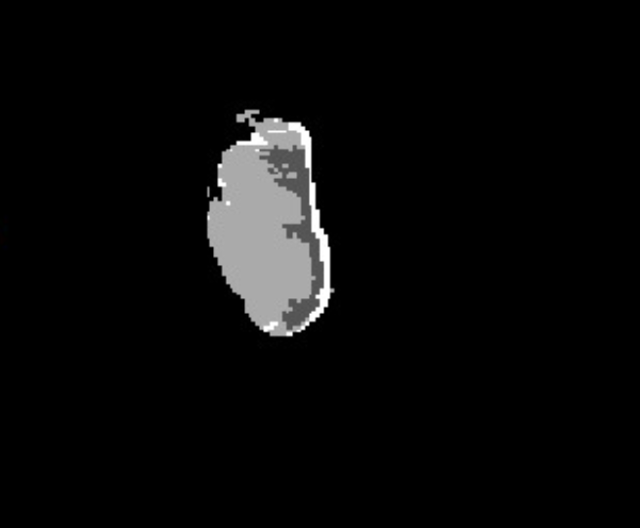
This multi-label segmentation map provides a comprehensive spatial representation of tumor heterogeneity, distinguishing biologically meaningful zones within the lesion. The labeling enables region-wise quantitative analysis..

CHAPTER 4
FEATURE EXTRACTION

1. Intensity Statistics Across Modalities and Subregions
This section computes histogram-based intensity features from different MRI modalities (T1, T1-Gd, and FLAIR) within the previously segmented tumor subregions (Enhancing Tumor, Tumor Core, and Peritumoral Edema).
For each modality–subregion pair, voxel intensities inside the corresponding binary mask are analyzed to derive statistical descriptors. The function extract_intensity_stats() calculates:
- Central tendency metrics: Mean, Median
- Dispersion metrics: Standard Deviation, Variance
- Extrema: Minimum, Maximum
- Shape descriptors: Skewness, Kurtosis
- Percentiles: 10th, 25th, 75th, and 90th percentiles
- Entropy: Computed from the normalized histogram to measure intensity randomness
The results are printed for all combinations of modalities and subregions, providing a quantitative profile of voxel intensity distributions across different tissue types and MRI contrasts.
Output
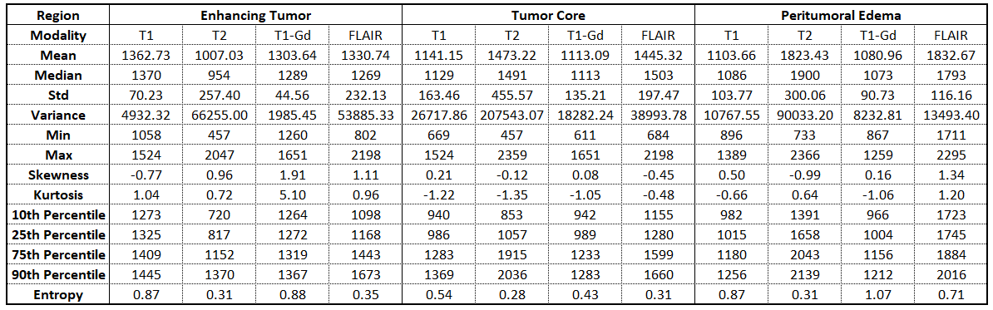

2. Geometric Statistics Across Subregions
This section extracts 3D morphological and structural features from each tumor subregion mask to describe its spatial and geometric properties.
The function extract_geometric_features() first labels connected regions in the binary mask, selects the largest component, and computes:
- Volume (voxels and mm³): Derived from voxel count and voxel spacing
- Surface Area (mm²): Estimated using the Marching Cubes algorithm
- Compactness: Ratio of volume to surface area, indicating shape regularity
- Elongation: Ratio of major to minor axis lengths, reflecting anisotropy
- Centroid: Geometric center coordinates of the region
- Bounding Box: 3D spatial extent of the subregion
The computed parameters are displayed for each subregion (Enhancing Tumor, Tumor Core, and Edema), providing insights into the tumor’s volume, morphology, and orientation.
Output
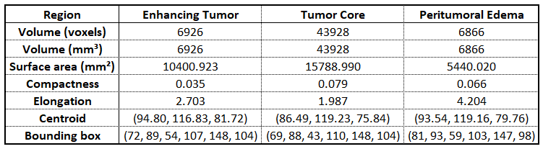

3. Texture / Radiomics Statistics Across Modalities and Subregions
This section extracts texture-based (radiomic) features from 2D slices of each MRI modality within the tumor subregions, quantifying spatial intensity variations and textural heterogeneity.
Three types of texture descriptors are computed:
- GLCM Features (Gray Level Co-occurrence Matrix):
Using graycomatrix() and graycoprops(), four key Haralick features are calculated — Contrast, Correlation, Energy, and Homogeneity — which capture the spatial relationship of gray-level intensities.
- Mahotas Haralick Features (GLRLM and GLSZM equivalents):
Computed via mahotas.features.haralick(), extracting Entropy (GLRLM-based) and Variance (GLSZM-based) to represent local complexity and variation within the texture.
- Local Binary Pattern (LBP) Features:
Using local_binary_pattern(), local neighborhood patterns are analyzed. A normalized histogram of LBP bins quantifies micro-texture variations within each subregion.
All extracted features are stored in a structured Pandas DataFrame, displaying feature values for every modality–subregion combination. This provides a comprehensive set of quantitative descriptors integrating intensity, geometry, and texture for further statistical or machine learning analysis.
Output
Modality | Subregion | GLCM Contrast | GLCM Corr | GLCM Energy | GLCM Homogeneity | GLRLM Entropy | GLSZM Variance | LBP Bin 0 | LBP Bin 1 | LBP Bin 2 | LBP Bin 3 | LBP Bin 4 | LBP Bin 5 | LBP Bin 6 | LBP Bin 7 | LBP Bin 8 | LBP Bin 9
T1 | Enhancing | 42.96 | 0.62 | 1.00 | 1.00 | 0.07 | 1.00 | 0.06 | 0.06 | 0.06 | 0.10 | 0.14 | 0.11 | 0.04 | 0.13 | 0.06 | 0.22
T1 | Core | 176.85 | 0.84 | 0.98 | 0.98 | 0.40 | 0.98 | 0.09 | 0.08 | 0.04 | 0.10 | 0.13 | 0.11 | 0.06 | 0.10 | 0.09 | 0.19
T1 | Edema | 79.83 | 0.68 | 1.00 | 1.00 | 0.09 | 0.99 | 0.12 | 0.16 | 0.02 | 0.05 | 0.07 | 0.09 | 0.04 | 0.12 | 0.12 | 0.21
T2 | Enhancing | 52.22 | 0.50 | 1.00 | 1.00 | 0.07 | 1.00 | 0.18 | 0.12 | 0.01 | 0.04 | 0.06 | 0.03 | 0.04 | 0.08 | 0.22 | 0.24
T2 | Core | 215.43 | 0.75 | 0.98 | 0.98 | 0.41 | 0.98 | 0.13 | 0.11 | 0.05 | 0.06 | 0.08 | 0.06 | 0.06 | 0.10 | 0.13 | 0.21
T2 | Edema | 60.93 | 0.71 | 0.99 | 1.00 | 0.10 | 0.99 | 0.11 | 0.13 | 0.04 | 0.10 | 0.09 | 0.07 | 0.05 | 0.11 | 0.12 | 0.18
T1-Gd | Enhancing | 61.39 | 0.37 | 1.00 | 1.00 | 0.07 | 1.00 | 0.18 | 0.06 | 0.03 | 0.03 | 0.03 | 0.05 | 0.01 | 0.20 | 0.19 | 0.19
T1-Gd | Core | 192.23 | 0.82 | 0.98 | 0.98 | 0.41 | 0.98 | 0.10 | 0.09 | 0.05 | 0.08 | 0.11 | 0.09 | 0.07 | 0.10 | 0.11 | 0.19
T1-Gd | Edema | 73.52 | 0.70 | 1.00 | 1.00 | 0.09 | 0.99 | 0.14 | 0.16 | 0.05 | 0.04 | 0.09 | 0.05 | 0.05 | 0.10 | 0.10 | 0.22
FLAIR | Enhancing | 51.40 | 0.51 | 1.00 | 1.00 | 0.07 | 1.00 | 0.15 | 0.12 | 0.04 | 0.04 | 0.04 | 0.03 | 0.06 | 0.11 | 0.16 | 0.27
FLAIR | Core | 247.12 | 0.68 | 0.98 | 0.98 | 0.41 | 0.98 | 0.11 | 0.11 | 0.03 | 0.05 | 0.08 | 0.07 | 0.07 | 0.10 | 0.14 | 0.23
FLAIR | Edema | 76.69 | 0.70 | 0.99 | 1.00 | 0.09 | 0.99 | 0.15 | 0.19 | 0.08 | 0.07 | 0.01 | 0.03 | 0.04 | 0.09 | 0.11 | 0.24

